

GentleTouch Respiratory Effort Patch, Disposable

Dymedix Diagnostics Inc. Phone : 888-212-1100
5985 Rice Creek Parkway; Ste 102 763-789-8280
Shoreview, MN 55126 USA email: info@dymedix.com
USA www.dymedix.com

Authorized European Representative:
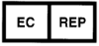MedEnvoy Global B.V.

Prinses Margrietplantsoen 33
Suite 123
2595AM The Hague
The Netherlands


Federal law (USA) restricts this device to sale by or on the order of a physician.

CAUTION
This product is for diagnostic purposes only and is not to be used in life supporting or life sustaining situations. Any serious incident that has occurred in relation to this device should be reported to Dymedix Diagnostics and the competent authority of the Member State in which the user and/or patient is established.

FEATURES AND INTENDED USE
The Dymedix GentleTouch Respiratory Effort Patch detects thoracic or abdominal respiratory effort related movements during diagnostic studies. This sensor is intended to produce a small electrical signal to existing recording equipment. The signal size can be adjusted by changing the settings on the recording equipment. This sensor must be used with a Dymedix GentleTouch Interface Cable.

PRECAUTIONS FOR SENSOR
- Store sensor at room temperature.
- Do not sterilize or reuse sensor.
- Use all available recorded parameters in making diagnosis.
- If there is no signal output from the sensor and it is properly placed on the patient discontinue use.
- If the unit is damaged or the adhesive will not stick discontinue use and discard.
- Sensors may damage the skin if removed carelessly.

Symbol | Definition of Symbol
 | Latex Free
   | Do not re-use
℞ | Federal Law (USA) restricts this device to sale by or on the order of a physician.
 | Consult instructions for use.
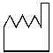 | Date of Manufacture  Expressed as: YYYYMMDD
 | Manufactured by
 | Medical Device

PATIENT INSTALLATION
- Remove the release liner from the back of the sensor to expose the adhesive surface.
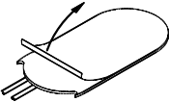
- Sensor should be placed similar to as shown below. Clinicians should look for areas on the chest or abdomen that provide the most breathing related movement and place there. Placing the sensor directly over the heart may result in cardiac oscillations in the waveform output. Apply the sensor to the clean and unbroken skin.
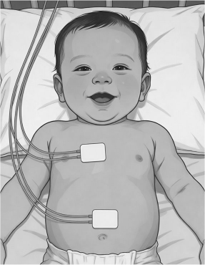
- Connect the sensor wires to the interface cable. Connect the interface cable to the input connections on the recording device.
- Proceed with diagnostic study as outlined by clinician procedure.

SENSOR REMOVAL INSTRUCTIONS
- After use, Disconnect sensor wires from interface cable.
- Gently peel the sensors from patient.
- Dispose of sensor as normal waste. Do not reuse.

WARRANTY
Dymedix warrants its sensors to be free from defects in materials and workmanship and to perform satisfactorily for One (1) Year from the date of purchase. Should the sensor fail, the sole liability of Dymedix is limited to replacement of the product with no charge for parts or labor. Under no circumstances shall Dymedix be liable for any consequential damages arising from the use of, or the inability to use this product. This warranty is rendered void for conditions resulting from: damage, marginal performance or malfunctions caused by: reuse, misuse, abuse, neglect, improper amplification settings, improper line voltage, power fluctuations, or any adverse environmental conditions, tampering, unauthorized modifications, adjustments or repairs to the product or its accessories. This warranty is in lieu of all other warranties, expressed or implied and is extended only to the original purchaser.

